实验一：熟悉java EE编程环境

实验内容：

创建学生数据库，建学生信息表（sno，sname，ssex，birthday，major）并输入几行数据。

参考本章案例，查询所有女生的信息。

实验步骤：

1. 创建maven项目，在pom.xml文件中配置依赖：MyBatis、mysql、Junit依赖
2. 创建module
3. 在resources下建db.properties、mybatis-config.xml文件。注意要在mybatis-config.xml文件中引入db.properties文件
4. 创建学生信息表并输入数据
5. 在src.main.java中建包com.pojo,包中创建学生表对应的POJO类，建包com.dao，包中定义接口StudentDAO，接口中定义查询女生的抽象方法。
6. 在src.main.resources中建包com.dao,包中建StudentMapper.xml文件，在文件中绑定接口com.dao.StudentDAO,定义查询映射语句。
7. 在mybatis-config.xml文件中注册StudentMapper.xml文件
8. 在Test.java目录中创建测试类。
9. 运行测试方法。

Student数据库

create table students  
*(* sno int auto_increment  
 primary key,  
 sname varchar*(*50*)* null,  
 ssex int null,  
 birthday datetime null,  
 major varchar*(*100*)* null  
*)*;

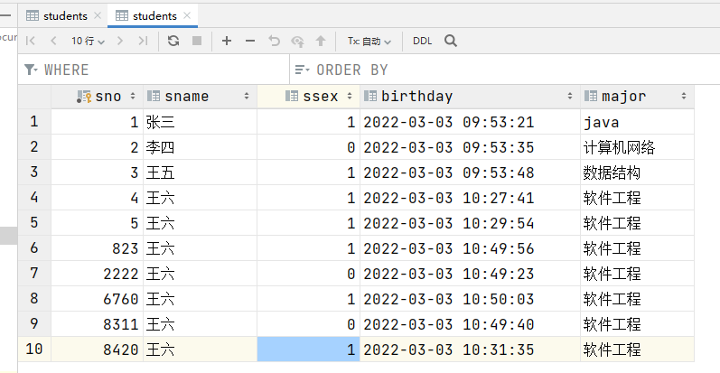

Students.java

package com.shf.pojo;  
  
import lombok.AllArgsConstructor;  
import lombok.Data;  
import lombok.NoArgsConstructor;  
  
import java.io.Serializable;  
import java.util.Date;  
  
@Data  
@AllArgsConstructor  
@NoArgsConstructor  
public class Students implements Serializable *{* private int sno;  
 private String sname;  
 private int ssex;  
 private Date birthday;  
 private String major;  
*}*

db.properties

driver=com.mysql.cj.jdbc.Driver  
url=jdbc:mysql://localhost:3306/mybatis?useSSL=true&useUnicode=true&characterEncoding=UTF-8  
username=root  
password=root

mybatis-config.xml

*<?*xml version="1.0" encoding="UTF-8" *?>  
<!DOCTYPE* configuration  
 PUBLIC "-//mybatis.org//DTD Config 3.0//EN"  
 "http://mybatis.org/dtd/mybatis-3-config.dtd"*>  
  
<*configuration*>  
  
 <!-- 引入外部配置文件-->  
 <*properties resource="db.properties"*/>  
  
 <*settings*>  
 <*setting name="logImpl" value="LOG4J"*/>  
 <*setting name="mapUnderscoreToCamelCase" value="true"*/>  
 <!-- 开启二级缓存-->  
 <*setting name="cacheEnabled" value="true"*/>  
 </*settings*>  
  
 <!-- 可以给实体类起别名-->  
 <*typeAliases*>  
 <!-- <typeAlias type="com.shf.pojo.Users" alias="user"/>-->  
 <*package name="com.shf.pojo"*/>  
 </*typeAliases*>  
  
 <*environments default="development"*>  
 <*environment id="development"*>  
 <*transactionManager type="JDBC"*/>  
 <*dataSource type="POOLED"*>  
 <*property name="driver" value="${driver}"*/>  
 <*property name="url" value="${url}"*/>  
 <*property name="username" value="${username}"*/>  
 <*property name="password" value="${password}"*/>  
 </*dataSource*>  
 </*environment*>  
 </*environments*>  
  
 <!-- 每一个MapperXML都需要在Mybatis配置中心注册-->  
 <*mappers*>  
 <!-- <mapper resource="com/shf/dao/UserMapper.xml"/>-->  
 <!-- <mapper class="com.shf.dao.UserMapper"/>-->  
 <*package name="com.shf.mapper"*/>  
 </*mappers*>  
</*configuration*>*

MyBatisUtils.java

package com.shf.utils;  
  
import org.apache.ibatis.io.Resources;  
import org.apache.ibatis.session.SqlSession;  
import org.apache.ibatis.session.SqlSessionFactory;  
import org.apache.ibatis.session.SqlSessionFactoryBuilder;  
  
import java.io.IOException;  
import java.io.InputStream;  
  
public class MyBatisUtils *{* private static SqlSessionFactory *sqlSessionFactory*;  
  
 static *{* try *{* String resource = "mybatis-config.xml";  
 InputStream inputStream = Resources.*getResourceAsStream(*resource*)*;  
 *sqlSessionFactory* = new SqlSessionFactoryBuilder*()*.build*(*inputStream*)*;  
 *}* catch *(*IOException e*) {* e.printStackTrace*()*;  
 *}  
 }* public static SqlSession getSqlSession*() {  
// 自动提交事物* return *sqlSessionFactory*.openSession*(*true*)*;  
 *}  
}*

StudentsMapper.java

package com.shf.mapper;  
  
import com.shf.pojo.Students;  
  
import java.util.List;  
  
public interface StudentsMapper *{* List*<*Students*>* getStudentList*()*;  
  
 Students getStudentById*(*int sno*)*;  
  
 void addStudent*(*Students students*)*;  
  
 void updateStudent*(*Students students*)*;  
  
 void deleteStudent*(*int sno*)*;  
  
 List*<*Students*>* getStudent*(*Students students*)*;  
*}*

StudentsMapper.xml

*<?*xml version="1.0" encoding="UTF-8" *?>  
<!DOCTYPE* mapper  
 PUBLIC "-//mybatis.org//DTD Config 3.0//EN"  
 "http://mybatis.org/dtd/mybatis-3-mapper.dtd"*>  
  
<*mapper namespace="com.shf.mapper.StudentsMapper"*>  
 <!-- 开启二级缓存-->  
 <*cache*/>  
  
 <!-- 获取全部-->  
 <*select id="getStudentList" resultType="students"*>* select *  
 from students;  
 *</*select*>  
  
 <!-- 获取一个-->  
 <*select id="getStudentById" resultType="students" parameterType="int"*>* select *  
 from students  
 where sno = #{sno};  
 *</*select*>  
  
 <!-- 添加-->  
 <*sql id="key"*>  
 <*trim suffixOverrides=","*>  
 <*if test="sno!=0"*>* sno,  
 *</*if*>  
 <*if test="sname!=null"*>* sname,  
 *</*if*>  
 <*if test="ssex!=0"*>* ssex,  
 *</*if*>  
 <*if test="birthday!=null"*>* birthday,  
 *</*if*>  
 <*if test="major!=null"*>* major,  
 *</*if*>  
 </*trim*>  
 </*sql*>  
 <*sql id="values"*>  
 <*trim suffixOverrides=","*>  
 <*if test="sno!=0"*>* #{sno},  
 *</*if*>  
 <*if test="sname!=null"*>* #{sname},  
 *</*if*>  
 <*if test="ssex!=null"*>* #{ssex},  
 *</*if*>  
 <*if test="birthday!=null"*>* #{birthday},  
 *</*if*>  
 <*if test="major!=null"*>* #{major},  
 *</*if*>  
 </*trim*>  
 </*sql*>  
 <*insert id="addStudent" parameterType="students"*>* insert into students (*<*include refid="key"*/>)* values *(<*include refid="values"*/>)*;  
 *</*insert*>  
  
 <!-- 更新-->  
 <*update id="updateStudent" parameterType="students"*>* update students  
 *<*set*>  
 <*if test="sname!=null"*>* sname=#{sname},  
 *</*if*>  
 <*if test="ssex!=null"*>* ssex=#{ssex},  
 *</*if*>  
 <*if test="birthday!=null"*>* ssex=#{birthday},  
 *</*if*>  
 <*if test="major!=null"*>* major=#{major},  
 *</*if*>  
 </*set*>* where sno=#{sno};  
 *</*update*>  
  
 <*delete id="deleteStudent" parameterType="int"*>* delete  
 from students  
 where sno = #{sno};  
 *</*delete*>  
  
 <*select id="getStudent" parameterType="students" resultType="students"*>* select *  
 from students  
 *<*where*>  
 <*if test="sno!=null and sno!=0"*>* and sno=#{sno}  
 *</*if*>  
 <*if test="sname!=null"*>* and sname=#{sname}  
 *</*if*>  
 <*if test="ssex!=null"*>* and ssex=#{ssex}  
 *</*if*>  
 <*if test="birthday!=null"*>* and ssex=#{birthday}  
 *</*if*>  
 <*if test="major!=null"*>* and major=#{major}  
 *</*if*>  
 </*where*>  
 </*select*>  
</*mapper*>*

StudentsTest.java

package com.shf.test;  
  
import com.shf.mapper.StudentsMapper;  
import com.shf.pojo.Students;  
import com.shf.utils.MyBatisUtils;  
import org.apache.ibatis.session.SqlSession;  
import org.junit.Test;  
  
import java.util.Date;  
import java.util.List;  
  
public class StudentsTest *{  
  
 // 查询所有学生* @Test  
 public void getStudentList*() {* SqlSession sqlSession = MyBatisUtils.*getSqlSession()*;  
 StudentsMapper mapper = sqlSession.getMapper*(*StudentsMapper.class*)*;  
 List*<*Students*>* studentList = mapper.getStudentList*()*;  
 for *(*Students student : studentList*) {* System.*out*.println*(*student*)*;  
 *}* sqlSession.close*()*;  
 *}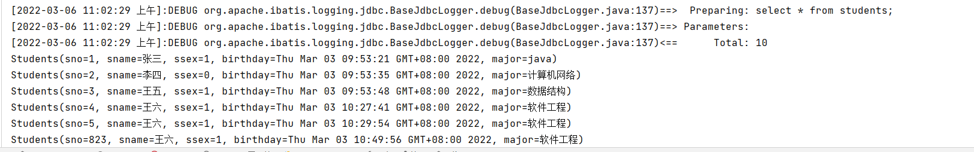 // 根据sno查询学生* @Test  
 public void getStudentById*() {* SqlSession sqlSession = MyBatisUtils.*getSqlSession()*;  
 StudentsMapper mapper = sqlSession.getMapper*(*StudentsMapper.class*)*;  
 Students studentById = mapper.getStudentById*(*1*)*;  
 System.*out*.println*(*studentById*)*;  
  
 sqlSession.close*()*;  
 *}*

 *// 添加学生* @Test  
 public void addStudent*() {* SqlSession sqlSession = MyBatisUtils.*getSqlSession()*;  
 StudentsMapper mapper = sqlSession.getMapper*(*StudentsMapper.class*)*;  
  
 Students student = new Students*(  
 (*int*) (*Math.*random()* * 10000*)*,  
 "王六",  
 1,  
 new Date*()*,  
 "软件工程"*)*;  
 System.*out*.println*(*student*)*;  
  
 mapper.addStudent*(*student*)*;  
  
 sqlSession.close*()*;  
 *}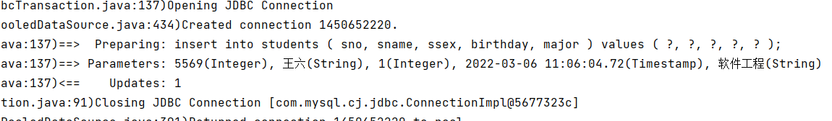 // 更新学生信息* @Test  
 public void updateStudent*() {* SqlSession sqlSession = MyBatisUtils.*getSqlSession()*;  
 StudentsMapper mapper = sqlSession.getMapper*(*StudentsMapper.class*)*;  
  
 Students student = new Students*()*;  
 student.setSno*(*1*)*;  
 student.setMajor*(*"java"*)*;  
 System.*out*.println*(*student*)*;  
  
 mapper.updateStudent*(*student*)*;  
  
 sqlSession.close*()*;  
 *}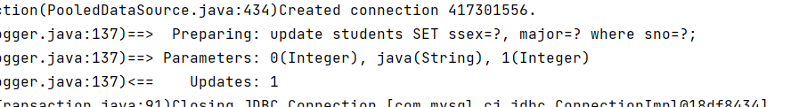 // 删除学生* @Test  
 public void deleteStudent*() {* SqlSession sqlSession = MyBatisUtils.*getSqlSession()*;  
 StudentsMapper mapper = sqlSession.getMapper*(*StudentsMapper.class*)*;  
  
 mapper.deleteStudent*(*6*)*;  
  
 sqlSession.close*()*;  
 *}  
  
 // 查询所有女生的信息* @Test  
 public void getStudent*() {* SqlSession sqlSession = MyBatisUtils.*getSqlSession()*;  
 StudentsMapper mapper = sqlSession.getMapper*(*StudentsMapper.class*)*;  
  
 Students students = new Students*()*;  
 students.setSsex*(*0*)*;  
 List*<*Students*>* studentList = mapper.getStudent*(*students*)*;  
 for *(*Students student : studentList*) {* System.*out*.println*(*student*)*;  
*}*

sqlSession.close*()*;  
 *} 